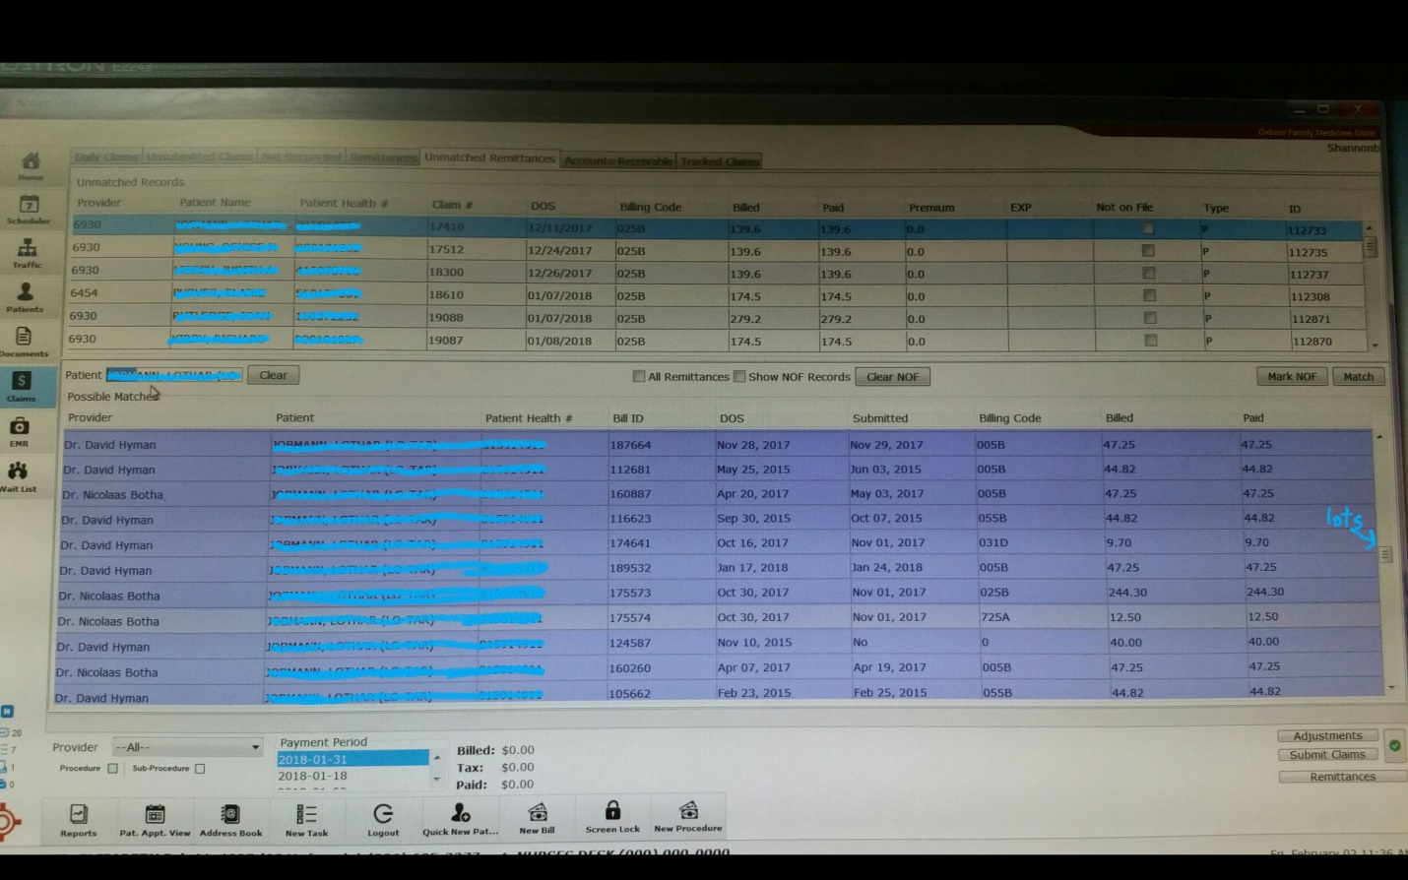
Random order cannot change
A lot to search thru

