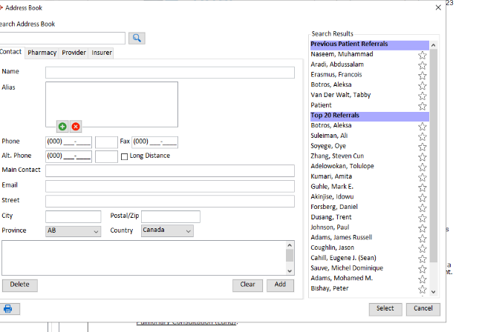

Able edit the physician a patient is no
Longer seeing. IE remove Dr. Naseem
From this list of physicians.

